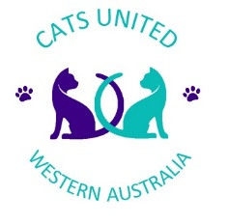
Cats United WA Inc.
MEMBER BODY OF CO-ORDINATING CAT COUNCIL OF AUSTRALIAN

TITLE APPLICATION

Name of Cat:____________________________________________ Reg No._____________________

Breed: _________________________________________________ Sex: ________________________

Colour: ________________________________________________ DOB: _______________________

Sire: __________________________________________ Dam: ____________________________________

Owners Details:

Name: ___________________________________________________________________________________

Address: __________________________________________________________________________________

Breeders Details:

Name: ___________________________________________________________________________________

Title Appling for:
(NB – 6 Challengers or 6 Awards of Merit from at least 3 different Judges are required)
☐ Champion | ☐ Premier | ☐ Double Title
☐ Grand Champion | ☐ Grand Premier
☐ Amber Grand Champion | ☐ Amber Grand Premier | ☐ Triple Title
☐ Garnet Grand Champion | ☐ Garnet Grand Premier
☐ Topaz Grand Champion | ☐ Topaz Grand Premier | ☐ Quadruple Title
☐ Opal Grand Champion | ☐ Opal Grand Premier
☐ Diamond Grand Champion | ☐ Diamond Grand Champion

PLEASE COMPLETE DETAILS OF CHALLENGER & AWARD OF MERIT IN DATE ORDER
No | Club Name | Show Date | Judges Name | Reg Body
1
2
3
4
5
6

☐Title Certificate (Un-Laminated) $10.00 |  | ☐ Title Certificate Laminated $15.00

Invoice will be issued upon approval

Please Email application along with certificates to:
Maree Carle
tlcpets@iinet.net.au

