Siberian & Others Cat Club
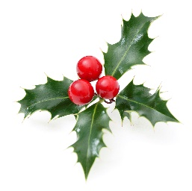
The Other
Christmas in July Show
Join us for a traditional Christmas Roast Dinner!
Discover fabulous prizes in our Raffle!
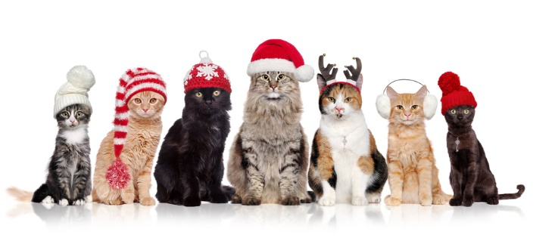
Dress your cage up to win even more prizes!

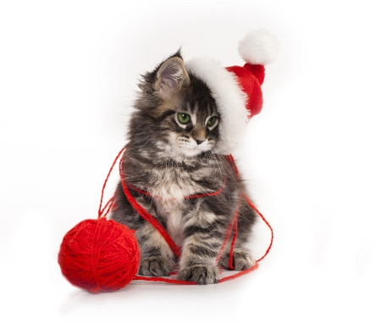
Sunday, 7th July 2019
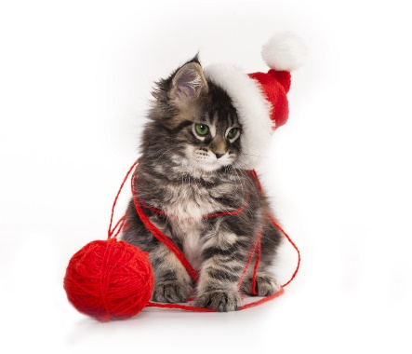
Fremantle Italian Club
65 Marine Terrace Fremantle

Junior Handler
Entry $5 per child | Two age divisions
6 to 12 years old | 13 to 17 years old
Winning points accumulated toward end of year Best Junior Exhibitor

Bank Details
BSB: 036 092| Acc: 197457| Name: Siberian & Others Cat Club | Bank: Westpac
Our Judges

Ring 1 – All Groups

Kerrith Wilkinson - CCCA

Like most children, I always had pet cats at home, though my first pedigreed cats were two Siamese. The first one I actually showed was a Blue Tabby Point called Budaya Blue Charro in 1979. Breeding: My cat breeding career moved in a different direction when I fell in love with British Shorthairs and obtained my first Blue girl, Barraby Miss Tiggywinkle in 1982. My prefix is Romsey, but I made a decision to stop breeding because I didn't like parting with the kittens I had bred. As a result, I moved into the area judging instead. Showing: My first British kitten won Best Victorian Bred Entire Kitten at her first Royal Melbourne Show in 1982. However, the best British I bred was Romsey Rum Tum Tugger, who did extremely well as a kitten in his first year on the bench in 1985. Clubs/Registration councils: I am and have always been a member of the Feline Control Council of Victoria, though I have other related interests in the cat world. I have been Vice President of Shorthair Cat Club and for a time in the mid–1980's I put a lot of energy into Yarra Valley Cat Club. Judging: Before I moved into judging, I stewarded for a number of years, but did my Group 3 (Shorthair other than Siamese–type) judging course in 1990. I have since obtained my Group 2 licence in 2004 and my Group 1 licence in 2010 making me an all breeds judge. I judge frequently for many clubs within Victoria, interstate and overseas. I judge frequently for many clubs within Victoria, interstate and overseas. I believe strongly that if a cat or kitten does not want to be shown, it should be left at home. This benefits the cat, the steward, judge and the owner in the long–run. No–one wants their cat marked "UTH" and the cat, who is the main concern, is happier.
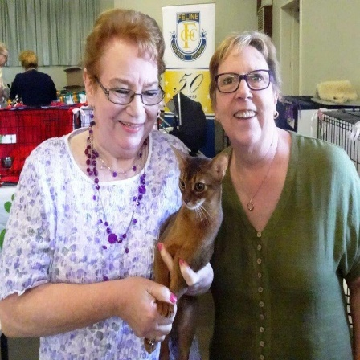
Ring 2 – All Groups

Barbara Martland – South Australia
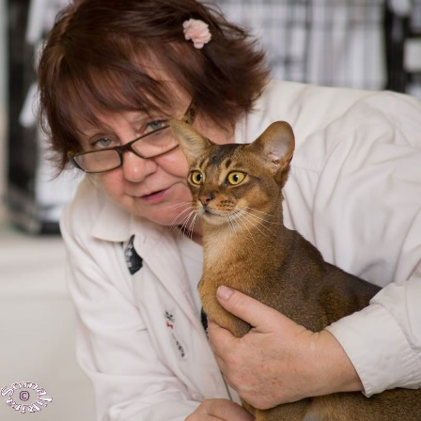
I have been involved with the cat fancy since 1971 when I registered my prefix Arrakish to breed Persian cat. I bred Persians for 18 years. During the last 43 years I have run many shows and held positions at FASA. I am currently Convener of Breeds and Standards and tutor for the current Shorthair Judging Course for FASA.

Along with my daughter, Kirsty, I have bred Exotics for the last 24 years. I love Tabbies and also Bi-Colours. I became a G1 Judge in the 1980s, G3 in 1999 and All Breeds in 2007. Along with cats, I have 3 daughters, 7 grandchildren and recently 3 great granddaughters. My youngest grandson often comes to shows with us now and enjoys being a Junior Exhibitor.
Thank you to our sponsors

Bliss Beds

Show Coordinators

Show Secretary: Michelle Harris 0413394625 sinavanya@iinet.net.au
Show Manager: Janis Thompson
Chief Steward: Pamela Lanigan
Trophy Steward: Narelle Topham
Kitchen: Janis & the Team

Entry Fees  Pedigree Cats $25.00  Pet Cats $13.00  Cage Hire $10.00 (Double or Single)  Printed Catalogue $5.00 | Christmas Dinner

Please advise on Entry Form whether you will bring your own Exhibition Cages and the size – Thank you!

Timetable  Hall Opens at 7.30am  Cats all in by 8.30am  Judging commences 9.00am  Public admitted 9.30 a.m. (approximately)  Show Closes 4.00pm  Please stay to help pack up | Entry Closing Date  Sunday, 30th June 2019  There is no late entry for this show  Once the software closes we cannot add your cats  Your entry will not be considered to be received until it is paid in full

Please note that cats may NOT be removed from the show before 5.00 p.m. unless pre-arranged with the Show Manager. Conducted under the Show Rules of the Cats United WA (Inc).

Thank you also to everyone who donated time and helped with set up and in other ways. It is greatly appreciated.

Please note that cats may NOT be removed from the show before closing, unless pre-arranged with the Show Manager. Conducted under the Show Rules of Cats United WA, which may be obtained from the Show Secretary.

Ring One - Kerrith Wilkinson
Ring 1 | Cage No | Cats Name
Supreme | 43 | AMBRITT HERE COMES RALPHIE - PAMELA LANIGAN
Judges Fancy | 23 | ZHIVAGO SPECIAL EDITION - JANIS THOMPSON
Best Group One Exhibit | 8 | ZHIVAGO ZEBASTIAN - JANIS THOMPSON
Best Siberian | 8 | ZHIVAGO ZEBASTIAN - JANIS THOMPSON
Reserve Siberian | 23 | ZHIVAGO SPECIAL EDITION - JANIS THOMPSON
Best Group One Entire | 8 | ZHIVAGO ZEBASTIAN - JANIS THOMPSON
Reserve Group One Entire | 6 | SUMMER SKYE MUZ - SUSAN GOODALL
3rd Group One Entire | 9 | ZHIVAGO JOJO - JANIS THOMPSON
Best Group One Kitten | 23 | ZHIVAGO SPECIAL EDITION - JANIS THOMPSON
Reserve Group One Kitten | 22 | BRITBLU IRRESISTABLE KISSES - BROOKE IRWIN
3rd Group One Kitten | 12 | ZHIVAGO LILLYANA - JANIS THOMPSON
4th Group One Kitten | 21 | SUPASWEET ALL READY TO HUSTLE - NARELLE TOPHAM
5th Group One Kitten | 17 | SINANVANYA ARANEL ANGEL FIRE - MICHELLE HARRIS
6th Group One | 28 | ZHIVAGO LADY SUMFIN SPECIAL - JANIS THOMPSON
Best Group One Desexed | 33 | SINANVANYA GANDALF THE GREY - MICHELLE HARRIS
Reserve Group One Desex | 30 | LOVEUFOREVER DAN - JUDY KLUCZNAIK
3rd Group One Desexed | 34 | ZHIVAGO MIA - MELITA BROWN
Best Group Two Exhibit | 37 | CH BAJIMBI QUEEN BEATRICE - CAROL ERCEG
Best Group Two Adult | 37 | CH BAJIMBI QUEEN BEATRICE - CAROL ERCEG
Best Group Two Kitten | 41 | BARADENE MOODY BLUES - CAROL ERCEG
Best Group Three Exhibit | 43 | AMBRITT HERE COMES RALPHIE - PAMELA LANIGAN
Best Group Three Entire | 43 | AMBRITT HERE COMES RALPHIE - PAMELA LANIGAN
Reserve group Three Entire | 42 | CUDDLETON BARON HERBERT - PAMELA LANIGAN
3rd Group Three Entire | 50 | GOLASH CSAR TCHAIKOVSKY - MILENA GOULD
4th Group Three Entire | 51 | TACHALI SILVER MAKS - MAREE CARLE
5th Group Three Entire | 45 | CUDDLETON BARONESS VIOLETA - PAMELA LANIGAN
Best Group Three Kitten | 69 | TACHALI BARONESS CHARLOTTE - MAREE CARLE
Reserve Group Three Kitten | 68 | TACHALI AURORA HARMONY - MAREE CARLE
3rd Group Three Kitten | 61 | CUDDLETON LADY CELESTE - PAMELA LANIGAN
4th Group Three Kitten | 67 | TACHALI METALLICA BLU LUKA - MAREE CARLE
5th Group Three Kitten | 62 | CUDDLETON DUKE BERNARD - PAMELA LANIGAN
6th Group Three Kitten | 72 | JENGARI STORM RIDER - DENISE WHILEY
Best Group Three Desexed | 77 | TACHALI CONTESSA TATIANA - MAREE CARLE
Reserve Group Three Desexed | 78 | DEJANUDE ARNIE WHATSAWHISKER - SUSAN GOODALL
Best Group Four Exhibit | 79 | SPIKE - TARA JACKSON
Reserve Group Four Desexed | 81 | WELLINGTON BEAR - SUSAN GOODALL

Ring Two - Barbara Martland
Ring 2 | Cage No | Cats Name
Supreme | 42 | CUDDLETON BARON HERBERT - PAMELA LANIGAN
Judges Fancy | 78 | DEJANUDE ARNIE WHATSAWHISKER - SUSAN GOODALL
Best Group One Exhibit | 9 | ZHIVAGO JOJO - JANIS THOMPSON
Best Siberian | 9 | ZHIVAGO JOJO - JANIS THOMPSON
Reserve Siberian | 28 | ZHIVAGO LADY SUMFIN SPECIAL - JANIS THOMPSON
Best Group One Entire | 9 | ZHIVAGO JOJO - JANIS THOMPSON
Reserve Group One Entire | 8 | ZHIVAGO ZEBASTIAN - JANIS THOMPSON
3rd Group One Entire | 6 | SUMMER SKYE MUZ - SUSAN GOODALL
Best Group One Kitten | 28 | ZHIVAGO LADY SUMFIN SPECIAL - JANIS THOMPSON
Reserve Group One Kitten | 23 | ZHIVAGO SPECIAL EDITION - JANIS THOMPSON
3rd Group One Kitten | 19 | RAGALON MAGIC STARDUCT - MELANIE HODDER & KRISTY GRIGG
4th Group One Kitten | 17 | SINANVANYA ARANEL ANGEL FIRE - MICHELLE HARRIS
5th Group One Kitten | 21 | SUPASWEET ALL READY TO HUSTLE - NARELLE TOPHAM
6th Group One | 22 | BRITBLU IRRESISTABLE KISSES - BROOKE IRWIN
Best Group One Desexed | 30 | LOVEUFOREVER DAN - JUDY KLUCZNAIK
Reserve Group One Desex | 34 | ZHIVAGO MIA - MELITA BROWN
3rd Group One Desexed | 33 | SINANVANYA GANDALF THE GREY - MICHELLE HARRIS
Best Group Two Exhibit | 41 | BARADENE MOODY BLUES - CAROL ERCEG
Best Group Two Adult | 37 | CH BAJIMBI QUEEN BEATRICE - CAROL ERCEG
Best Group Two Kitten | 41 | BARADENE MOODY BLUES - CAROL ERCEG
Best Group Three Exhibit | 42 | CUDDLETON BARON HERBERT - PAMELA LANIGAN
Best Group Three Entire | 42 | CUDDLETON BARON HERBERT - PAMELA LANIGAN
Reserve group Three Entire | 43 | AMBRITT HERE COMES RALPHIE - PAMELA LANIGAN
3rd Group Three Entire | 51 | TACHALI SILVER MAKS - MAREE CARLE
4th Group Three Entire | 48 | ALMERICE LOUIS-FRANÇOIS CARTIER - TROY & LISA SCADDAN
5th Group Three Entire | 56 | TWILI CATTY NOIR - AMBER MCALLAN
Best Group Three Kitten | 74 | JENGARI AVALON MIST - DENISE WHILEY
Reserve Group Three Kitten | 61 | CUDDLETON LADY CELESTE - PAMELA LANIGAN
3rd Group Three Kitten | 69 | TACHALI BARONESS CHARLOTTE - MAREE CARLE
4th Group Three Kitten | 62 | CUDDLETON DUKE BERNARD - PAMELA LANIGAN
5th Group Three Kitten | 68 | TACHALI AURORA HARMONY - MAREE CARLE
6th Group Three Kitten | 70 | ISLAREY OPAL - DENISE WHILEY
Best Group Three Desexed | 78 | DEJANUDE ARNIE WHATSAWHISKER - SUSAN GOODALL
Reserve Group Three Desexed | 77 | TACHALI CONTESSA TATIANA - MAREE CARLE
Best Group Four Exhibit | 79 | SPIKE - TARA JACKSON
Reserve Group Four Desexed | 81 | WELLINGTON BEAR - SUSAN GOODALL

CCCA Awards
CCCA Awards | Ring 1 | Ring 2
Group One Male | 2 | N/A
Group One Female | 5 | 5
Group One Neuter | 30 | 30
Group One Spey | 0 | 0
Group Two Male
Group Two Female
Group Two Neuter
Group Two Spey
Group Three Male | 43 | 43
Group Three Female | 53 | 56
Group Three Neuter | 75 | W/H
Group Three Spey | 77 | 77

Please note: CCCA Awards are only awarded to titled cats from CCCA and ACF affiliates.

Group One Adult

Neva Masquerade

Class 10 : RED TABBY POINT Male Open
1 | ZHIVAGO ZACCOSTALOT - Rego: CU19082, DOB: 9/9/2018, Sire: NEVA ANGELS FACTOR X - SEAL TABBY POINT & WHITE, Dam: ZHIVAGO JOJO - SIBERIAN - BLACK GOLDEN SPOTTED TABBY, Exh: JANIS THOMPSON, Bdr: Exhibitor

Exhibit | Ring 1 | Ring 2
1 | Yes | Yes
Challenge | 1 | 1

Class 20 : SEAL TABBY POINT & WHITE Male Open
2 | TICA TPL GD CH NEVA ANGELS FACTOR X - Rego: FS1433/2016, DOB: 17/1/2016, Sire: QDC KUZKIN DOM MAGNUS/WC - COLOURPOINT SEAL SILVER TABBY - SEAL SILVER TABBY POINT, Dam: QDC LUCIA SNOW MAGIC - COLOURPOINT SEAL TABBY WITH WHITE - SEAL TABBY POINT & WHITE, Exh: JANIS THOMPSON, Bdr: A MITIC & M VLAHOVIC

Exhibit | Ring 1 | Ring 2
2 | Yes | Yes
Challenge | 2 | 2

Ragdoll

Class 30 : SEAL POINT Female Open
3 | SINANVANYA LADY BELLA - Rego: 486W18/CU18, DOB: 26/11/2017, Sire: DIAMONDDOLL ALADIN - SEAL POINT BICOLOR, Dam: SINANVANYA LADY OF LORIEN - SEAL POINT, Exh: MICHELLE HARRIS, Bdr: Exhibitor
4 | GLD GD CH SILHOUETTE TOUCHED BY A FAIRIE - Rego: 16GC28957/W16/CU18, DOB: 14/10/2015, Sire: ACF AOE, DBL GD CH & PLAT DBL GD CH XOXO TOUCH OF CLASS KISSES - BLUE POINT, Dam: CH SILHOUETTE OF A FAIRIETAYLE - SEAL POINT BICOLOR, Exh: NARELLE TOPHAM, Bdr: E Buckley

Exhibit | Ring 1 | Ring 2
3 | 2 | 2
4 | 1 | 1
Challenge | 4 | 4

Class 40 : BLUE POINT Female Open
5 | BRZ GD CH JAIHAYSCO TOOTCEE PUSS - Rego: 383W17, DOB: 26/1/2017, Sire: GD CH S*KRICKELINS ROSSINI - SEAL POINT MITTED, Dam: GLD GD CH SILHOUETTE TOUCH BY A FAIRIE - SEAL POINT, Exh: NARELLE TOPHAM, Bdr: Exhibitor

Exhibit | Ring 1 | Ring 2
5 | Yes | Yes
Challenge | 5 | 5

Class 50 : LILAC POINT Male Open
6 | SUMMER SKYE MUZ - Rego: 553W18/CU18, DOB: 12/2/2018, Sire: Loveuforever MR Tiramisu - CHOCOLATE POINT, Dam: Diamonddoll Dreaming DiAmonds - BLUE POINT, Exh: SUSAN GOODALL, Bdr: Exhibitor

Exhibit | Ring 1 | Ring 2
6 | Yes | Yes
Challenge | 6 | 6

Class 60 : SEAL POINT MITTED Female Open
7 | JAIHAYSCO CHOCCY BEAR - Rego: 025CU18, DOB: 28/9/2018, Sire: HAPPYTIME CHARISMAGIC-BT - SEAL POINT BICOLOR, Dam: DBL GR CH & ACF AOE, SUMIBO MISS ROXETTE - BLUE POINT, Exh: NARELLE TOPHAM, Bdr: Exhibitor

Exhibit | Ring 1 | Ring 2
7 | Yes | Yes
Challenge | 7 | 7

Siberian

Class 70 : Black Golden Male Open
8 | ZHIVAGO ZEBASTIAN - Rego: 430W17, DOB: 27/1/2017, Sire: ZHIVAGO HUGO BOSS - BLACK MACKEREL TABBY & WHITE, Dam: ZHIVAGO ANASTASIYA - BLACK MACKEREL TABBY, Exh: JANIS THOMPSON, Bdr: Exhibitor

Exhibit | Ring 1 | Ring 2
8 | Yes | Yes
Challenge | 8 | 8

Class 80 : Black Golden Female Open
9 | ZHIVAGO JOJO (Black Golden Mackerel tabby and white) - Rego: 423W17, DOB: 5/2/2017, Sire: ZHIVAGO PRINCE HARRY - RED MACKEREL TABBY & WHITE, Dam: SNOWGUM ELSA - NEVA MASQUARADE - SEAL POINT, Exh: JANIS THOMPSON, Bdr: Exhibitor

Exhibit | Ring 1 | Ring 2
9 | Yes | Yes
Challenge | 9 | 9

Class 90 : WHITE Female Open
10 | CH NEVA ANGELS MASTERPIECE - Rego: FS1830/2018/CU18, DOB: 2/1/2018, Sire: RW QGC JELLY BEAN TAIGA STAR OF NEVA ANGELS - WHITE, Dam: DBL GD CH NEVA ANGELS DIAMOND IN THE SKY - NEVA MASQUARADE - BLUE SILVER TABBY POINT, Exh: JANIS THOMPSON, Bdr: Ana Viahovic & Petra Skundrica

Exhibit | Ring 1 | Ring 2
10 | Yes | Yes
Challenge | 10 | 10

Top Group One Adults
Place | Ring 1 | Ring 2
Best
Reserve
3rd

Group One Kitten

Exotic

Class 100 : BLACK SMOKE BICOLOR Neutered Kitten Under 9 Months
11 | TWOMOR HOLLY SMOKE - Rego: 19QC7246 (slv), DOB: 20/11/2018, Sire: PDGH TWOMOR PANTALOON PANDA - BLACK BICOLOR, Dam: TWOMOR PEACH MELBA - BLUE TORTIE BICOLOR, Exh: CAROL ERCEG, Bdr: Denis and Trish Morrison

Exhibit | Ring 1 | Ring 2
11 | Yes | Yes

Neva Masquerade

Class 110 : SEAL TABBY POINT Female Kitten Under 7 Months
12 | ZHIVAGO LILLYANA - Rego: CU19117, DOB: 8/12/2018, Sire: NEVA ANGELS FACTOR X - SEAL TABBY POINT & WHITE, Dam: NEVA ANGELS JENNY WALKER - BLUE TABBY POINT, Exh: JANIS THOMPSON, Bdr: Ana Mitic

Exhibit | Ring 1 | Ring 2
12 | Yes | Yes

Ragdoll

Class 120 : SEAL POINT Male Kitten Under 7 Months
13 | LOVEUFOREVER THEODORE - Rego: CU19155, DOB: 4/2/2019, Sire: GD CH KRICKELINS ROSSINI*S - SEAL POINT MITTED, Dam: FANCYRAGS SOPHIE BELL - SEAL POINT, Exh: NARELLE TOPHAM, Bdr: Janis Thompson

Exhibit | Ring 1 | Ring 2
13 | Yes | Yes

Class 130 : SEAL POINT Female Kitten Under 9 Months
14 | BRITBLU SECRET KISSES - Rego: 19CO14, DOB: 15/11/2018, Sire: CH. SILHOUETTE OF A PERFECT STORM - LILAC POINT, Dam: BRITBLU ANGEL OF MUSIC - SEAL POINT MITTED, Exh: BROOKE IRWIN, Bdr: Exhibitor

Exhibit | Ring 1 | Ring 2
14 | Yes | Yes

Class 140 : BLUE POINT Male Kitten Under 9 Months
15 | SINANVANYA ARAN ELESSAR - Rego: CU19060, DOB: 17/11/2018, Sire: LOVEUFOREVER A STAR IS BORN - SEAL POINT, Dam: SINANVANYA ARANEL VANYA - BLUE POINT, Exh: MICHELLE HARRIS, Bdr: Exhibitor

Exhibit | Ring 1 | Ring 2
15 | Yes | Yes

Class 150 : BLUE POINT Female Kitten Under 5 Months
16 | BRITBLU PRECIOUS GEMSTONE - Rego: tba, DOB: 14/3/2019, Sire: CH. SILHOUETTE OF A PERFECT STORM - LILAC POINT, Dam: SUMIBO SAPPHIRE SURPRISE - SEAL POINT, Exh: BROOKE IRWIN, Bdr: Exhibitor

Exhibit | Ring 1 | Ring 2
16 | Yes | Yes

Class 160 : BLUE POINT Female Kitten Under 9 Months
17 | SINANVANYA ARANEL ANGEL FIRE - Rego: CU19059, DOB: 17/11/2018, Sire: LOVEUFOREVER A STAR IS BORN - SEAL POINT, Dam: SINANVANYA ARANEL VANYA - BLUE POINT, Exh: MICHELLE HARRIS, Bdr: Exhibitor

Exhibit | Ring 1 | Ring 2
17 | Yes | Yes

Class 170 : LILAC POINT Female Kitten Under 7 Months
18 | WOMBLETOWN SNOWY RIVER CHARDONNEY - Rego: 19V35848/CU19, DOB: 10/1/2019, Sire: ROSECOLOURED ORINOCO - BLUE POINT, Dam: ROSECOLOURED MARSANNE - BLUE POINT MITTED, Exh: SONIA DORLING & GABRIELLA DORLING, Bdr: Exhibitor

Exhibit | Ring 1 | Ring 2
18 | ABS | ABS

Class 180 : SEAL POINT BICOLOR Female Kitten Under 7 Months
19 | RAGALON MAGIC STARDUCT - Rego: PENDING, DOB: 20/12/2018, Sire: KOC POL SHOGUN - BLUE POINT BICOLOR, Dam: RAGALON KIAMI - SEAL POINT MITTED, Exh: MELANIE HODDER & KRISTY GRIGG, Bdr: Pam Baker

Exhibit | Ring 1 | Ring 2
19 | Yes | Yes

Class 190 : SEAL POINT MITTED Male Kitten Under 7 Months
20 | ROSECOLOURED MI TOBERMORY - Rego: 19V35848/CU19, DOB: 11/1/2019, Sire: JIPSIGLENN VOULEZ VOUS RAGDOLL - SEAL POINT, Dam: ROSECOLOURED MON AME RAGDOLL - SEAL POINT MITTED, Exh: SONIA DORLING & GABRIELLA DORLING, Bdr: Judith Barry

Exhibit | Ring 1 | Ring 2
20 | ABS | ABS

Class 200 : BLUE POINT MITTED Male Kitten Under 9 Months
21 | SUPASWEET ALL READY TO HUSTLE - Rego: 19GC29926, DOB: 18/11/2018, Sire: GLD CH SILHOUETTE OF A HUSTLER - SEAL POINT, Dam: CZ* YANNA AZRAG BEY - BLUE TABBY POINT BICOLOR, Exh: NARELLE TOPHAM, Bdr: S Buckley

Exhibit | Ring 1 | Ring 2
21 | Yes | Yes

Class 210 : BLUE POINT MITTED Female Kitten Under 9 Months
22 | BRITBLU IRRESISTABLE KISSES - Rego: 19CO15, DOB: 15/11/2018, Sire: CH. SILHOUETTE OF A PERFECT STORM - LILAC POINT, Dam: BRITBLU ANGEL OF MUSIC - SEAL POINT MITTED, Exh: BROOKE IRWIN, Bdr: Exhibitor

Exhibit | Ring 1 | Ring 2
22 | Yes | Yes

Siberian

Class 220 : BLACK MACKEREL TABBY Male Kitten Under 7 Months
23 | ZHIVAGO SPECIAL EDITION - Rego: CU19089, DOB: 19/12/2018, Sire: ZHIVAGO PRINCE HARRY - RED MACKEREL TABBY, Dam: SNOWGUM TATTYANNA - BLACK SPOTTED TABBY & WHITE, Exh: JANIS THOMPSON, Bdr: Exhibitor

Exhibit | Ring 1 | Ring 2
23 | Yes | Yes

Class 230 : RED MACKEREL TABBY Neutered Kitten Under 7 Months
24 | ZHIVAGO GEORGI - Rego: CU19133, DOB: 20/1/2019, Sire: ZHIVAGO ZEBASTIAN - BLACK MACKEREL TABBY & WHITE, Dam: ZHIVAGO LADY IN RED - RED MACKEREL TABBY & WHITE, Exh: SUE & BRUCE NORTON, Bdr: Janis Thompson

Exhibit | Ring 1 | Ring 2
24 | Yes | Yes

Class 240 : BLACK MACKEREL TABBY & WHITE Neutered Kitten Under 9 Months
25 | ZHIVAGO YURI - Rego: CU 19137, DOB: 7/11/2018, Sire: SHEMIAKA BOSLEY - BLUE MACKEREL TABBY, Dam: ZHIVAGO SHARLA - BLACK MACKEREL TABBY & WHITE, Exh: SUE & BRUCE NORTON, Bdr: Janis Thompson

Exhibit | Ring 1 | Ring 2
25 | Yes | Yes

Class 250 : RED MACKEREL TABBY & WHITE Male Kitten Under 7 Months
26 | ZHIVAGO HARRY - Rego: CU19136, DOB: 20/1/2019, Sire: Zhivago Zebastian - BLACK MACKEREL TABBY & WHITE, Dam: Zhivago Lady in Red - RED MACKEREL TABBY, Exh: JANIS THOMPSON, Bdr: Exhibitor

Exhibit | Ring 1 | Ring 2
26 | Yes | Yes

Class 260 : BLACK SPOTTED TABBY & WHITE Female Kitten Under 5 Months
27 | NADEZHDA PRETTY AS A PICTURE - Rego: CU19147, DOB: 16/3/2019, Sire: ZHIVAGO JUST A DREAM - BLACK SPOTTED TABBY & WHITE, Dam: ZHIVAGO WISH UPON A STAR - Black Golden, Exh: KIM WALLACE, Bdr: Exhibitor

Exhibit | Ring 1 | Ring 2
27 | Yes | Yes

Class 270 : BLACK SPOTTED TABBY & WHITE Female Kitten Under 9 Months
28 | ZHIVAGO LADY SUMFIN SPECIAL - Rego: CU19087, DOB: 30/11/2018, Sire: NEVA ANGELS FACTOR X - NEVA MASQUARADE - SEAL TABBY POINT & WHITE, Dam: ZHIVAGO ANASTASIA - BLACK MACKEREL TABBY, Exh: JANIS THOMPSON, Bdr: Exhibitor

Exhibit | Ring 1 | Ring 2
28 | Yes | Yes

Top Group One Kittens
Place | Ring 1 | Ring 2
Best
Reserve
3rd
4th
5th
6th

Group One Desex

Neva Masquerade

Class 280 : SEAL TABBY POINT Neutered Open
29 | ZHIVAGO MARCEL - Rego: 365W18, DOB: 10/12/2017, Sire: NEVA ANGLES FACTOR X - SEAL TABBY POINT & WHITE, Dam: SNOWGUM ELSA - SIBERIAN - BLACK SPOTTED TABBY, Exh: JUDY KLUCZNAIK, Bdr: Janis Thompson

Exhibit | Ring 1 | Ring 2
29 | Yes | Yes
Challenge | 29 | 29

Ragdoll

Class 290 : LILAC POINT Neutered Open
30 | TPL PR & DBL GLD GD CH LOVEUFOREVER DAN - Rego: W13/12CO354CU18, DOB: 15/12/2011, Sire: CH KIWIMAGIC THE POWER OF LOVE - LILAC POINT, Dam: SHAYRAGS MINUTE OF MADNESS - CHOCOLATE POINT, Exh: JUDY KLUCZNAIK, Bdr: J THOMPSON

Exhibit | Ring 1 | Ring 2
30 | Yes | Yes
Challenge | 30 | 30

Class 300 : RED POINT Neutered Open
31 | RIVENDOLL OLIVER TWIST - Rego: 15COX266, DOB: 18/1/2015, Sire: Rivendoll Daja Bleu - BLUE POINT BICOLOR, Dam: Mikidz Shaydes Shades of Autumn of Rivendoll - SEAL TORTIE POINT, Exh: MELITA BROWN, Bdr: Exhibitor

Exhibit | Ring 1 | Ring 2
31 | Yes | Yes
Challenge | 31 | 31

Class 310 : SEAL POINT MITTED Neutered Open
32 | TPL GD PR & DBL GLD GD CH LOVEUFOREVER MR BENJAMIN - Rego: 11COX337CU18, DOB: 10/2/2011, Sire: FANCYRAGS MR CHURCHILL - BLUE POINT MITTED, Dam: GUYSNDOLLS BELLADONNA - SEAL POINT, Exh: JUDY KLUCZNAIK, Bdr: J THOMPSON

Exhibit | Ring 1 | Ring 2
32 | Yes | Yes
Challenge | 32 | 32

Class 320 : BLUE POINT MITTED Neutered Open
33 | SINANVANYA GANDALF THE GREY - Rego: 657W17CU18/CU18, DOB: 5/3/2017, Sire: SINANVANYA MR CHURCHILL - BLUE POINT BICOLOR, Dam: SHAY RAGS ANNA MARIE - SEAL POINT, Exh: MICHELLE HARRIS, Bdr: Exhibitor

Exhibit | Ring 1 | Ring 2
33 | Yes | Yes
Challenge | 33 | 33

Siberian

Class 330 : BLACK MACKEREL TABBY Spayed Open
34 | ZHIVAGO MIA - Rego: 402W16, DOB: 17/11/2015, Sire: Shemiaka Bosley - BLUE MACKEREL TABBY, Dam: Snowgum Anastasiya - BLACK MACKEREL TABBY, Exh: MELITA BROWN, Bdr: Janis Thompson

Exhibit | Ring 1 | Ring 2
34 | Yes | Yes
Challenge | 34 | 34

Class 340 : CREAM MACKEREL TABBY & WHITE Neutered Open
35 | SHEMIAKA CHRISTO NOEL - Rego: Pending, DOB: 9/9/2016, Sire: Shemiaka Obsession - BLACK SILVER MACKEREL TABBY & WHITE, Dam: Sibmore Valiska - BLACK TORTIE & WHITE, Exh: MELITA BROWN, Bdr: Sherrie Noble

Exhibit | Ring 1 | Ring 2
35 | Yes | Yes
Challenge | 35 | 35

Class 350 : BLACK GOLDEN SHADED Neutered Open
36 | GD CH MIASIBKA MIDAS - Rego: 1043W10/CU18, DOB: 15/9/2010, Sire: IWAN ZIMNEJ KRAINY*PL - GOLDEN MACKEREL TABBY & WHITE - BLACK & WHITE, Dam: MIASIBKA ANYA - BLUE SILVER TORTIE TABBY - BLUE SILVER CLASSIC TORTIE TABBY, Exh: JUDY KLUCZNAIK, Bdr: J Wheeler

Exhibit | Ring 1 | Ring 2
36 | Yes | Yes
Challenge | 36 | 36

Top Group One Desex
Place | Ring 1 | Ring 2
Best
Reserve
3rd

Group Two Adult

Oriental

Class 360 : BLACK SPOTTED TABBY SHORTHAIR Female Open
37 | DB GR CHAMPION CH BAJIMBI QUEEN BEATRICE - Rego: 45652, DOB: 5/1/2018, Sire: DBL GD CH & NAT CH AZOV RED BACK - CHOCOLATE SHORTHAIR, Dam: NAT GD CH BAJIMBI PURE PASSION - CHOCOLATE SILVER SPOTTED TABBY SHORTHAIR, Exh: CAROL ERCEG, Bdr: B Edwards

Exhibit | Ring 1 | Ring 2
37 | Yes | Yes
Challenge | 37 | 37

Class 370 : BLACK SMOKE SHORTHAIR Female Open
38 | GR CHAMPION CAROLANN BLACK JU JU - Rego: 45857, DOB: 24/1/2018, Sire: DBL GD CH & NAT CH BAJIMBI CLASSIC BEXTA - CHOCOLATE SILVER CLASSIC TABBY SHORTHAIR, Dam: DBL GD CH EBONY QUEEN OF POP - BLACK SHORTHAIR, Exh: CAROL ERCEG, Bdr: Exhibitor

Exhibit | Ring 1 | Ring 2
38 | Yes | Yes
Challenge | 38 | 38

Top Group Two Adults
Place | Ring 1 | Ring 2
Best
Reserve

Oriental

Class 380 : BLACK SILVER MACKEREL TABBY SHORTHAIR Male Kitten Under 5 Months
39 | CAROLANN ALEXANDER - Rego: 49416, DOB: 15/2/2019, Sire: ANCATS SAPPHIRE DB GR CH & ANCATS NATIONAL CH BAJIMBI CLASSIC BEXTA - CHOCOLATE SILVER CLASSIC TABBY SHORTHAIR, Dam: ANCATS GR CH NANLOW CHOCOLATE DIVA - CHOCOLATE SMOKE SHORTHAIR, Exh: CAROL ERCEG, Bdr: Exhibitor

Exhibit | Ring 1 | Ring 2
39 | Yes | Yes

Class 390 : CHOCOLATE SILVER SPOTTED TABBY SHORTHAIR Female Kitten Under 9 Months
40 | CAROLANN SILVER CASCADE - Rego: 48234, DOB: 30/10/2018, Sire: BAJIMBI CLASSIC BEXTA - CHOCOLATE SILVER CLASSIC TABBY SHORTHAIR, Dam: CAROLANN PANDORA’S BOX - CHOCOLATE SILVER SPOTTED TABBY SHORTHAIR, Exh: CAROL ERCEG, Bdr: Exhibitor

Exhibit | Ring 1 | Ring 2
40 | UTJ | Yes

Class 400 : BLUE BICOLOR SHORTHAIR Male Kitten Under 9 Months
41 | BARADENE MOODY BLUES - Rego: CVI 2/7083, DOB: 26/11/2018, Sire: BARADENE DEAL THE CARDS - BLUE BICOLOR SHORTHAIR, Dam: BARADENE CALL ME DIVA - SIAMESE - SEAL POINT, Exh: CAROL ERCEG, Bdr: Matthew Branaugh

Exhibit | Ring 1 | Ring 2
41 | Yes | Yes

Top Group Two Kittens
Place | Ring 1 | Ring 2
Best
Reserve

Group Three Adult

British Shorthair

Class 410 : BLUE Male Open
42 | CUDDLETON BARON HERBERT - Rego: 692W18/CU18, DOB: 16/4/2018, Sire: CUDDLETON LORD WALLACE - BLUE BICOLOR, Dam: PLT GD CH AMBRITT POETRY IN MOTION - BLUE , Exh: PAMELA LANIGAN, Bdr: Exhibitor
43 | SLV ACF AOE, ACF NAT CH, SUP CH & DBL GLD GD CH AMBRITT HERE COMES RALPHIE - Rego: QFA13/306291/W14/CU18, DOB: 9/3/2013, Sire: BRZ DBL GD CH AMBRITT PEARL JAMMIN EDDIE - BLUE , Dam: AMBRIT FORGET ME NOT - BLUE , Exh: PAMELA LANIGAN, Bdr: J & A MAAS
44 | GR CH ZAINIZA JIMMY CHOO - Rego: (MY)KKMLO1083/17/BSH, DOB: 10/2/2017, Sire: AMBRIATI COOKIE MONSTER - BLUE , Dam: GIC ZAINIZA ROWENA - BLUE BICOLOR, Exh: TROY & LISA SCADDAN, Bdr: M Zain

Exhibit | Ring 1 | Ring 2
42 | 2 | 1
43 | 1
44 | 3
Challenge | 43 | 42

Class 420 : BLUE Female Open
45 | CUDDLETON BARONESS VIOLETA - Rego: 694W18/CU18, DOB: 16/4/2018, Sire: CUDDLETON LORD WALLACE - BLUE BICOLOR, Dam: PLT GD CH AMBRITT POETRY IN MOTION - BLUE , Exh: PAMELA LANIGAN, Bdr: Exhibitor
46 | CHARIOT OF FREYA RADIO GAGA - Rego: CU19008, DOB: 5/9/2018, Sire: CH INTRIGUE RUMOUR HAS IT - BLUE , Dam: BRITBLU CANDY CRUSH - BLUE , Exh: BRIANA GUY, Bdr: Exhibitor

Exhibit | Ring 1 | Ring 2
45 | 1
46 | ABS | ABS
Challenge | 45

Class 430 : BLUE BICOLOR Female Open
47 | AMBRITT TIME SPENT TOGETHER - Rego: QFA17/311201/541W17, DOB: 20/11/2016, Sire: SLV DBL GD CH Ambritt Shamrock Shooter - BLUE BICOLOR, Dam: Ambritt Janis Joplin - BLUE , Exh: PAMELA LANIGAN, Bdr: J & A Mass

Exhibit | Ring 1 | Ring 2
47 | Yes | Yes
Challenge | 47 | 47

Class 440 : LILAC BICOLOR Male Open
48 | ALMERICE LOUIS-FRANÇOIS CARTIER - Rego: KKMLO1746/18/BSH/CU18, DOB: 22/2/2018, Sire: INT GD CH ORPHEUS WINTEROSE OF ZAINIZA - FAWN BICOLOR, Dam: OLANA LOCUSTA STYLE - BLUE , Exh: TROY & LISA SCADDAN, Bdr: M. Rahman

Exhibit | Ring 1 | Ring 2
48 | Yes | Yes
Challenge | 48 | 48

Class 450 : CINNAMON BICOLOR Male Open
49 | CH QUIDO HONEYPIE (IMP CZ) - Rego: (CZ)CSCHLO346/16/BSH, DOB: 27/3/2016, Sire: GIC PAUILLAC HONORABLE - FAWN, Dam: EVELINA NEW MONTEMI - CINNAMON BICOLOR, Exh: PAMELA LANIGAN, Bdr: M Sotnarova

Exhibit | Ring 1 | Ring 2
49 | Yes | Yes
Challenge | 49 | 49

Russian

Class 460 : BLUE Male Open
50 | SLV GD CH GOLASH CSAR TCHAIKOVSKY - Rego: 13CO100/W14/CU18, DOB: 3/10/2012, Sire: BLUICE AUSTIN - BLUE, Dam: CH KEEHOTAY ANICI ANGELOU - BLUE, Exh: MILENA GOULD, Bdr: Exhibitor
51 | ACF NAT CH, ACF AOE, CCCA NAT CH, DB DI GR CH (COAWA) & CATSWA PT GD CH & CH TACHALI SILVER MAKS - Rego: 05CO600/W14/CU18, DOB: 3/8/2005, Sire: UKI PHANTOM FURY OF KIMARA - BLUE, Dam: CH TACHALI ZENA - BLUE, Exh: MAREE CARLE, Bdr: Exhibitor

Exhibit | Ring 1 | Ring 2
50 | 1 | 2
51 | 2 | 1
Challenge | 50 | 51

Class 470 : BLUE Female Open
52 | GOLASH ANGEL SILVER DUST - Rego: CU19001, DOB: 1/10/2018, Sire: KIMARA BLU SHIMMA DRUID - BLUE, Dam: CH KEEHOTAY ANICI ANGELOU - BLUE, Exh: MILENA GOULD, Bdr: Exhibitor
53 | CH TACHALI REGAL ATHENA - Rego: 253W17, DOB: 14/11/2016, Sire: KIMARA BLU SHIMMA DRUID - BLUE, Dam: TACHALI KLASSIC SILVER MARRA - BLUE, Exh: MAREE CARLE, Bdr: Exhibitor
54 | TACHALI GRAND NINA - Rego: 72W18/CU18, DOB: 21/9/2017, Sire: KIMARA BLU SHIMMA DRUID - BLUE, Dam: UKI MAISIE RAINE - BLUE, Exh: MAREE CARLE, Bdr: Exhibitor
55 | GOLASH BLU BAYOU - Rego: 799W15/CU18, DOB: 30/8/2015, Sire: SILVER GR CH GOLASH CSAR TCHAIKOVSKY - BLUE, Dam: GOLASH BRILLIANT RED POPPY - BLUE, Exh: MILENA GOULD, Bdr: Exhibitor

Exhibit | Ring 1 | Ring 2
52 | 4
53 | 3
54 | 2 | 2
55 | 1 | 1
Challenge | 55 | 55

Class 480 : BLACK Female Open
56 | CH TWILI CATTY NOIR - Rego: 664W16/CU18, DOB: 1/6/2016, Sire: SLV GD CH GOLASH CSAR TCHAIKOVSKY - BLUE, Dam: TWILI PEPPER POTTS - BLACK, Exh: AMBER MCALLAN, Bdr: Exhibitor

Exhibit | Ring 1 | Ring 2
56 | Yes | Yes
Challenge | 56 | 56

Top Group Three Adults
Place | Ring 1 | Ring 2
Best
Reserve
3rd
4th
5th

Group Three Kitten

British Shorthair

Class 490 : BLUE Male Kitten Under 5 Months
57 | CHARIOT OF FREYA BLUE STEEL - Rego: Tba4, DOB: 11/4/2019, Sire: CH INTRIGUE RUMOUR HAS IT - BLUE , Dam: BRITBLU CANDY CRUSH - BLUE , Exh: BRIANA GUY, Bdr: Exhibitor

Exhibit | Ring 1 | Ring 2
57 | ABS | ABS

Class 500 : BLUE Female Kitten Under 5 Months
58 | CHARIOT OF FREYA FERREIRA - Rego: TBA 11, DOB: 11/4/2019, Sire: CH INTRIGUE RUMOUR HAS IT - BLUE , Dam: BRITBLU CANDY CRUSH - BLUE , Exh: BRIANA GUY, Bdr: Exhibitor
59 | CHARIOT OF FREYA LE TIGRE - Rego: Tba3, DOB: 11/4/2019, Sire: CH INTRIGUE RUMOUR HAS IT - BLUE , Dam: BRITBLU CANDY CRUSH - BLUE , Exh: BRIANA GUY, Bdr: Exhibitor
60 | CHARIOT OF FREYA AQUA VITAE - Rego: Tba1, DOB: 11/4/2019, Sire: CH INTRIGUE RUMOUR HAS IT - BLUE , Dam: BRITBLU CANDY CRUSH - BLUE , Exh: BRIANA GUY, Bdr: Exhibitor

Exhibit | Ring 1 | Ring 2
58 | ABS | ABS
59 | ABS | ABS
60 | ABS | ABS

Class 510 : FAWN Female Kitten Under 7 Months
61 | CUDDLETON LADY CELESTE - Rego: CU19101, DOB: 14/12/2018, Sire: BRZ GD CH QUIDO HONEYPIE (IMP CZ) - CINNAMON BICOLOR, Dam: CUDDLETON LADY CHARLOTTE - LILAC , Exh: PAMELA LANIGAN, Bdr: Exhibitor

Exhibit | Ring 1 | Ring 2
61 | Yes | Yes

Class 520 : BLUE BICOLOR Male Kitten Under 5 Months
62 | CUDDLETON DUKE BERNARD - Rego: CU19156, DOB: 26/3/2019, Sire: SLV ACF AOE, ACF NAT CH, SUP CH & DBL GLD GD CH AMBRITT HERE COMES RALPHIE - BLUE , Dam: CUDDLETON DUCHESS SIMONE - BLUE BICOLOR, Exh: PAMELA LANIGAN, Bdr: Exhibitor

Exhibit | Ring 1 | Ring 2
62 | Yes | Yes

Class 530 : BLUE BICOLOR Female Kitten Under 9 Months
63 | CHARIOT OF FREYA JEWEL OF THE NILE - Rego: CU19006, DOB: 10/10/2018, Sire: OBANYA LILAC WILBUR - LILAC , Dam: MISKRY TEA ROSE - BLUE BICOLOR, Exh: BRIANA GUY, Bdr: Exhibitor

Exhibit | Ring 1 | Ring 2
63 | ABS | ABS

Class 540 : CINNAMON TORTIE BICOLOR Female Kitten Under 9 Months
64 | CUDDLETON FRAU HEIDI - Rego: CU19044, DOB: 9/10/2018, Sire: BRZ GD CH QUIDO HONEYPIE (IMP CZ) - CINNAMON BICOLOR, Dam: CRYSTAL FLAMES YAMAICA - GEN4 - CINNAMON TORTIE BICOLOR, Exh: PAMELA LANIGAN, Bdr: Exhibitor

Exhibit | Ring 1 | Ring 2
64 | ABS | ABS

Class 550 : CHOCOLATE VAN Female Kitten Under 7 Months
65 | MERILYNS CINNABUN FOR COCATROLIS - Rego: Pending, DOB: 7/2/2019, Sire: RAUSCHERS GEORGIO - CINNAMON BICOLOR, Dam: COCATROLIS GIGI HADID - CHOCOLATE BICOLOR, Exh: TROY & LISA SCADDAN, Bdr: M. Biddle

Exhibit | Ring 1 | Ring 2
65 | Yes | Yes

Russian

Class 560 : BLUE Male Kitten Under 5 Months
66 | TACHALI MISTER BEAU - Rego: Pending, DOB: 18/3/2019, Sire: TACHALI CZAR ANAKIN - BLUE, Dam: CH TACHALI REGAL ATHENA - BLUE, Exh: MAREE CARLE, Bdr: Exhibitor
67 | TACHALI METALLICA BLU LUKA - Rego: Pending, DOB: 27/2/2019, Sire: ACF NAT CH, ACF AOE, CCCA NAT CH, DB DI GR CH & CATS WA PT GD CH & CH TACHALI SILVER MAKS - BLUE, Dam: KIMARA BLU SHIMMA ASCHEA - BLUE, Exh: MAREE CARLE, Bdr: Exhibitor

Exhibit | Ring 1 | Ring 2
66 | 2 | 2
67 | 1 | 1

Class 570 : BLUE Female Kitten Under 7 Months
68 | TACHALI AURORA HARMONY - Rego: Pending, DOB: 1/2/2019, Sire: SLV GD CH GOLASH CSAR TCHAIKOVSKY - BLUE, Dam: TACHALI CROWN CHRYSTAL - BLUE, Exh: MAREE CARLE, Bdr: Exhibitor

Exhibit | Ring 1 | Ring 2
68 | Yes | Yes

Class 580 : BLUE Female Kitten Under 9 Months
69 | TACHALI BARONESS CHARLOTTE - Rego: Pending, DOB: 27/11/2018, Sire: TACHALI CZAR ANAKIN - BLUE, Dam: TACHALI DUCHESS BLOSSOM - BLUE, Exh: MAREE CARLE, Bdr: Exhibitor

Exhibit | Ring 1 | Ring 2
69 | Yes | Yes

Selkirk Rex

Class 590 : Blue Golden Shaded Shorthair Female Kitten Under 9 Months
70 | ISLAREY OPAL - Rego: pending, DOB: 10/11/2018, Sire: AMAZOLOU HULLABALOO - BLUE GOLDEN SHADED BRITISH SHORTHAIR - (None), Dam: ISLAREY OLIVIA - (None), Exh: DENISE WHILEY, Bdr: Exhibitor

Exhibit | Ring 1 | Ring 2
70 | Yes | Yes

Class 600 : BLUE SPOTTED TABBY SHORTHAIR Female Kitten Under 9 Months
71 | ISLAREY RIPLEY - Rego: pending, DOB: 17/10/2018, Sire: ISLAREY EXCELENTRY ENTRY - (None), Dam: ISLAREY SWEETY - (None), Exh: DENISE WHILEY, Bdr: Exhibitor

Exhibit | Ring 1 | Ring 2
71 | Yes | Yes

Class 610 : BLUE BICOLOR SHORTHAIR Male Kitten Under 5 Months
72 | JENGARI STORM RIDER - Rego: CVI :3/4564(S), DOB: 22/3/2019, Sire: CH. Brighthills Sambua - BLACK SMOKE BICOLOR SHORTHAIR, Dam: Rebuss Jakkalberry - BLACK TORTIE SILVER SHADED LONGHAIR, Exh: DENISE WHILEY, Bdr: Ms Jennifer Rewell

Exhibit | Ring 1 | Ring 2
72 | Yes | Yes

Class 620 : CHOCOLATE BICOLOR SHORTHAIR Female Kitten Under 7 Months
73 | MISSTOFFELEES AMARYLLIS - Rego: Cu19121, DOB: 31/12/2018, Sire: EMIKOO BLAME IT ON THE BOSA NOVA - BLACK SMOKE BICOLOR SHORTHAIR, Dam: EMIKOO SWEET DEMERARA - CHOCOLATE SMOKE BICOLOR SHORTHAIR, Exh: SUE GUY, Bdr: Exhibitor

Exhibit | Ring 1 | Ring 2
73 | ABS | ABS

Class 630 : BLACK SILVER SPOTTED TABBY BICOLOR SHORTHAIR Female Kitten Under 9 Months
74 | JENGARI AVALON MIST - Rego: 3/4560, DOB: 24/11/2018, Sire: Jengari White Knight - BLACK SILVER TABBY VAN SHORTHAIR, Dam: Purrcurls Ingrid Bergman - BLACK SILVER SHADED SHORTHAIR, Exh: DENISE WHILEY, Bdr: J REWELL

Exhibit | Ring 1 | Ring 2
74 | Yes | Yes

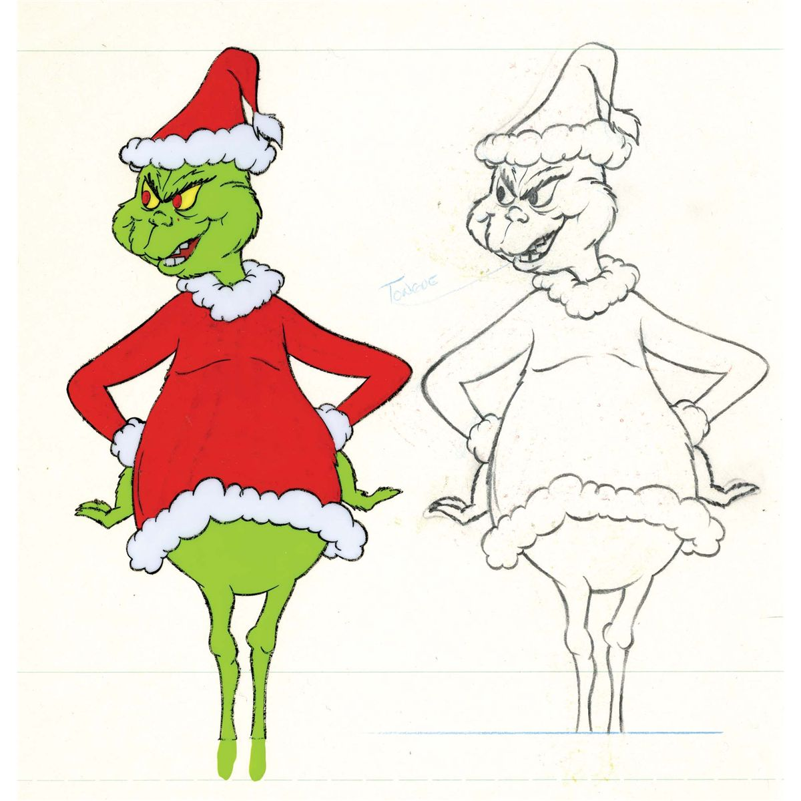
Top Group Three Kittens
Place | Ring 1 | Ring 2
Best
Reserve
3rd
4th
5th
6th

Group Three Desex

Abyssinian

Class 640 : TAWNY Neutered Open
75 | BR GR PR OSIRIS (V) MINECRAFT WARRIER - Rego: QFA16/309959/W16, DOB: 10/10/2015, Sire: ACF AOE, GLD DBL GD CH OSIRIS (V) HEARTS PERFECTION - TAWNY, Dam: DBL GD CH OSIRIS(V) OZZIE OZZIE - TAWNY, Exh: VICTORIA CAYLEY & JAMES PRITCHARD, Bdr: M & S Shawn

Exhibit | Ring 1 | Ring 2
75 | Yes | Yes
Challenge | 75 | 75

Australian Mist

Class 650 : BLUE SPOTTED Neutered Open
76 | SILVERADO BLUEY (Blue Spotted) - Rego: 42104, DOB: 18/9/2016, Sire: Thera Hungerford - LILAC SPOTTED, Dam: Silerado Regita - BLUE SPOTTED, Exh: ERIC CASEY & , Bdr: Joan and Ken Quinn

Exhibit | Ring 1 | Ring 2
76 | Yes | Yes
Challenge | 76 | 76

Russian

Class 660 : BLUE Spayed Open
77 | SLV GD CH TACHALI CONTESSA TATIANA - Rego: 11CO109/W14/CU18, DOB: 12/12/2010, Sire: BARISHKA PRINCE ANDREI - BLUE, Dam: TACHALI JEWEL ZOE - BLUE, Exh: MAREE CARLE, Bdr: Exhibitor

Exhibit | Ring 1 | Ring 2
77 | Yes | Yes
Challenge | 77 | 77

Sphynx

Class 670 : RED POINT Neutered Open
78 | DEJANUDE ARNIE WHATSAWHISKER - Rego: 12W18/CU18, DOB: 20/7/2017, Sire: Nuderanch Beauregarde Maverick (ImpNZ) - , Dam: CH Amenophis Manga - , Exh: SUSAN GOODALL, Bdr: Sharon Wood

Exhibit | Ring 1 | Ring 2
78 | Yes | Yes
Challenge | 78 | 78

Top Group Three Desex
Place | Ring 1 | Ring 2
Best
Reserve

Group Four Desex

Companion Pet

Class 680 : SHORTHAIR Neutered Open
79 | SPIKE (Black silver ) - Rego: 11CO321/W15/CU18, DOB: 2/3/2011, Sire: - , Dam: - , Exh: TARA JACKSON, Bdr: Exhibitor

Exhibit | Ring 1 | Ring 2
79 | Yes | Yes

Class 690 : LONGHAIR Neutered Open
80 | TOBY (Bi colour blue point) - Rego: -, DOB: 21/6/2013, Sire: - , Dam: - , Exh: VICTORIA CAYLEY & JAMES PRITCHARD, Bdr: Exhibitor
81 | WELLINGTON BEAR (Chocolate Mitted) - Rego: 537W16/CU18, DOB: 10/3/2016, Sire: - , Dam: - , Exh: SUSAN GOODALL, Bdr: Exhibitor

Exhibit | Ring 1 | Ring 2
80 | 2 | 2
81 | 1 | 1

Class 700 : LONGHAIR Spayed Open
82 | ARWEN (Seal tortie and white) - Rego: 735W15/CU18, DOB: 3/3/2015, Sire: - , Dam: - , Exh: MICHELLE HARRIS, Bdr: Exhibitor

Exhibit | Ring 1 | Ring 2
82 | Yes | Yes

Top Group Four Desex
Place | Ring 1 | Ring 2
Best
Reserve

Thank you to our Exhibitors
for supporting

Siberian &
Others Cat Club

Exhibitors List

Name | Association | State | Phone | Email | Exhibit No's
MELITA BROWN | CatsUnited | WA |  | tiegan490@gmail.com | 31, 34, 35
MAREE CARLE | CatsUnited | WA | 08 9317 4479 | tlcpets@iinet.net.au | 51, 53, 54, 66, 67, 68, 69, 77
ERIC CASEY | ANCATS | WA | 0473568339 | ericcasey048@gmail.com | 76
VICTORIA CAYLEY  JAMES PRITCHARD | CATSWA | WA | 0415631220 | cayleythoroughbreds@bigpond.com | 75, 80
SONIA DORLING  GABRIELLA DORLING | CatsUnited | WA |  |  | 18, 20
CAROL ERCEG | ANCATS | WA |  |  | 11, 37, 38, 39, 40, 41
SUSAN GOODALL | CatsUnited | WA | 0407479931 | susanskysum1@bigpond.com | 6, 78, 81
MILENA GOULD | CatsUnited | WA | 08 9394 0467 | mgould2@slb.com | 50, 52, 55
SUE GUY | CatsUnited | WA |  | subi2257@hotmail.com | 73
BRIANA GUY | CatsUnited | WA | 0430552023 | chariotoffreya@outlook.com | 46, 57, 58, 59, 60, 63
MICHELLE HARRIS | CatsUnited | WA | 0413 394625 | sinanvanya@iinet.net.au | 3, 15, 17, 33, 82
MELANIE HODDER  KRISTY GRIGG | COAWA | WA | 0403431264 | melhodder67@gmail.com | 19
BROOKE IRWIN | COAWA | WA | 0894552481 | britblucats@hotmail.com | 14, 16, 22
TARA JACKSON | CatsUnited | WA | 08 9317 4477 | taracarle2003@yahoo.com.au | 79
JUDY KLUCZNAIK | CatsUnited | WA |  | terjk@bigpond.com | 29, 30, 32, 36
PAMELA LANIGAN | CatsUnited | WA |  | cuddleton@optiic.com | 42, 43, 45, 47, 49, 61, 62, 64
AMBER MCALLAN | CatsUnited | WA |  | MGould2@slb.com | 56
SUE & BRUCE NORTON | CatsUnited | WA |  | suenorton@iprimus.com.au | 24, 25
TROY & LISA SCADDAN | CatsUnited | WA |  |  | 44, 48, 65
JANIS THOMPSON | CatsUnited | WA | 08 95238027 | loveuforeverragdolls@hotmail.com | 1, 2, 8, 9, 10, 12, 23, 26, 28
NARELLE TOPHAM | CatsUnited | WA | 0419968606 | colandrel@bigpond.com | 4, 5, 7, 13, 21
KIM WALLACE | CatsUnited | WA | 0433124702 | kimwallace.au@gmail.com | 27
DENISE WHILEY | CatsUnited | WA | 0403869933 | denise.whiley@yahoo.com | 70, 71, 72, 74

